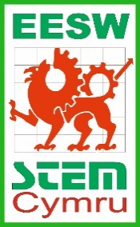
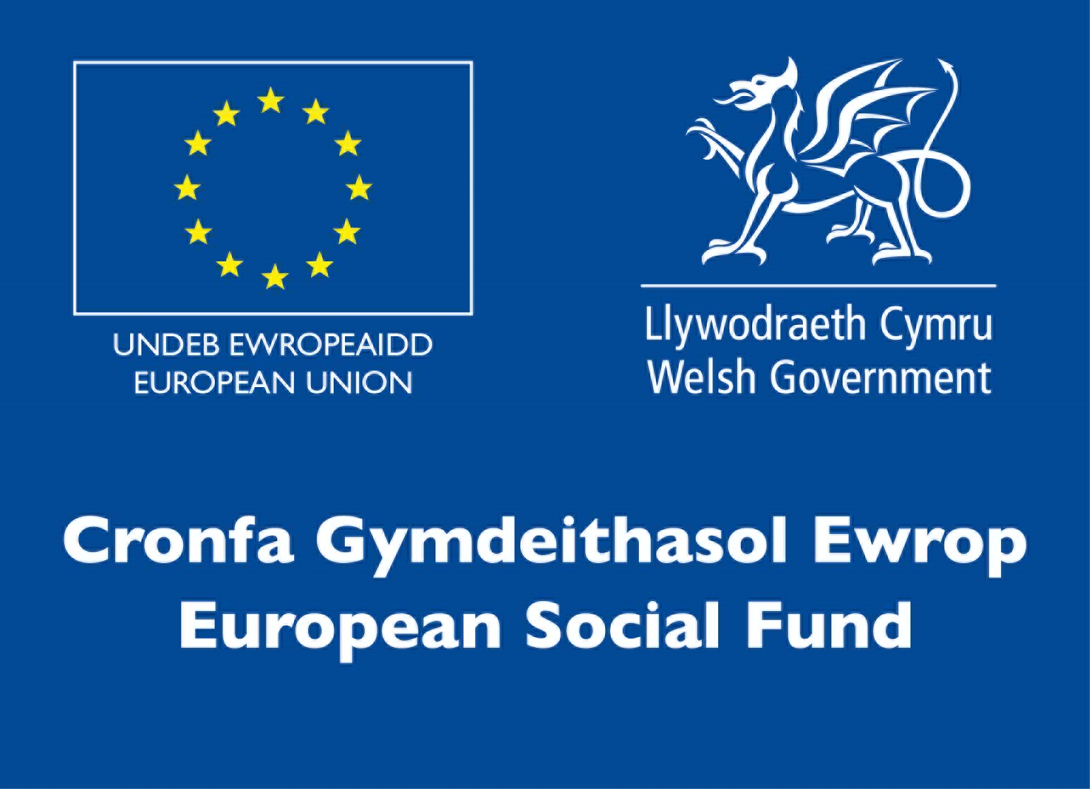
EESW Project 2021-2022
School Partnership Agreement

The Engineering Education Scheme Wales project links teams of sixth form students to an industry to enable them to engage with a real engineering problem with the support of a company engineer. The experience adds value to their school curriculum and develops a number of personal skills and qualities:
- Enhanced STEM skills and understanding
- Essential and employability skills
- Problem solving
- Teamwork
- Improving own learning
- Industrial awareness
- Confidence in communicating with others

All students are encouraged to enter for a Gold CREST Award. There is also the opportunity to use the experience for the accreditation of Essential/Key Skills and will satisfy the assessment criteria for the Enterprise and Employability Challenge and Individual Investigation sections of the Welsh Baccalaureate.
To enable this, EESW will commit to providing the following:
- An EESW representative to set up the project including welcome events, workshops, awards and presentation days and to provide assistance throughout your project.
- A company link
- A link project engineer
- A welcome event
- A two/three-day workshop
- An Awards and Presentation Day
- The potential to win an award to the value of up to £500
We ask that the school commits to:
- Ensuring the team completes the project
- Returning the necessary documentation to EESW when required
- Reading the Health and Safety document and ensuring participating students abide by these guidelines at all times.

I confirm that my school is willing to commit to the above. I confirm that I have read the EESW/STEMCymru Privacy Notice (available at www.stemcymru.org.uk) and consent to my information being used for the purposes indicated. I also give consent for my details to be shared with my link school/company for the purposes of the EESW Project 2021-2022.
Print: Sign:
Date: School:
Prosiect EESW 2021-2022
Cytundeb Partneriaeth Ysgol

Mae gweithgarwch Cynllun Addysg Peirianneg Cymru yn cysylltu timau o fyfyrwyr chweched dosbarth â diwydiant fel y gallant ddatrys problem peirianneg go iawn gyda chymorth peiriannydd cwmni. Mae’r profiad yn ychwanegu gwerth at eu cwricwlwm ysgol ac yn datblygu nifer o sgiliau a rhinweddau personol:
- Gwella sgiliau a dealltwriaeth o STEM
- Sgiliau hanfodol a chyflogadwyedd
- Datrys problemau
- Gwaith tîm
- Gwella’ch dysgu
- Ymwybyddiaeth ddiwydiannol
- Hyder wrth gyfathrebu ag eraill

Anogir pob myfyriwr i ymgeisio am Wobr CREST Aur. Mae yna gyfle hefyd i ddefnyddio’r profiad i achredu Sgiliau Hanfodol/Allweddol, a bydd yn bodloni’r meini prawf asesu ar gyfer adrannau Her Menter a Chyflogadwyedd ac Ymchwiliad Unigol Bagloriaeth Cymru.
I alluogi hyn, bydd EESW yn ymrwymo i ddarparu’r canlynol:
- Amser cynrychiolydd EESW mewn sesiynau sefydlu, gweithdai a’r diwrnodau gwobrwyo a chyflwyno a chymorth gydol eich prosiect.
- Cyswllt â chwmni
- Peiriannydd prosiect cyswllt
- Digwyddiad sefydlu
- Gweithdy dau/tri diwrnod
- Diwrnod Gwobrwyo a Chyflwyno o fri
- Y potensial i ennill gwobr o hyd at £500 (£50 i bob myfyriwr, a’r gweddill i’r ysgol)

Gofynnir i’r ysgol ymrwymo i’r canlynol:
- Sicrhau bod y tîm yn cyflawni’r prosiect
- Dychwelyd y dogfennau angenrheidiol i EESW yn ôl yr angen
- Darllen y ddogfen iechyd a diogelwch amgaeedig a sicrhau bod y myfyrywyr sy'n cymryd rhan yn cadw at yr arweiniad hwn bob amser.

Rwy’n cadarnhau fy mod wedi darllen Hysbysiad Preifatrwydd EESW/STEMCymru (sydd ar gael yn www.stemcymru.org.uk) ac yn rhoi caniatâd i chi ddefnyddio fy ngwybodaeth at y dibenion a nodwyd. Hefyd, rwy’n fodlon i’m manylion gael eu rhannu â’r ysgol/cwmni cyswllt at ddibenion Prosiect STEMCymru 2021-2022.
Enw: Llofnod:
Dyddiad: Ysgol:

