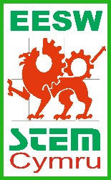
On the road to cleaner air - Competition guide
Your mission is to design a road sign to encourage drivers to keep to the 50mph average
speed limit.
What should your road sign look like?
- Keep the message short and snappy and remember in Wales, traffic signs must show the same message in both Welsh and English.
- Make the image bold, with sharp lines.
- Use strong and contrasting colours to make your image and message stand out.
To be eligible for the competition your design must be on A4 and in in portrait format.
The closing date for the competition is 17th January 2022.
The winning entry will be scaled up to a full-size sign with the help of a graphic designer and used on roads across Wales! Good luck!
Submit your designs to info@eesw.org.uk or post them to EESW, Waterton Centre, Bridgend, CF31 3WT.
Don’t forget to include your name and school on your template!

Write the Welsh version of the message here. If you don’t speak Welsh, don’t worry! Leave it blank and this will be translated for you

Colour the border and background in any two contrasting colours.

Write the English version of the message here. If you don’t speak English, don’t worry! Leave it blank and this will be translated for you

Draw the image in this square. Remember that this will be seen by passing cars so keep it clear and simple.

