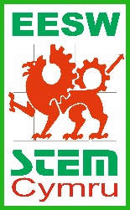
On the road to cleaner air - Competition guide
Did you know that one of the leading causes of air pollution comes from traffic? Cars, buses and lorries emit a range of pollutants, including nitrogen oxide. Encouraging drivers to slow can reduce this pollution and make the air cleaner.
Your mission is to design a road sign to encourage drivers to slow down.
What should my road sign look like?
- Keep the message short and snappy and remember in Wales, traffic signs must show the same message in both Welsh and English.
- Make the image bold, with sharp lines. The sign must be seen and understood by someone driving a car. Small details will not be seen.
- Use strong and contrasting colours to make your image and message stand out.

To be eligible for the competition your design must be on A4 and in in portrait format.
The closing date for the competition is 17th January 2022.
The winning entry will be scaled up to a full-size sign with the help of a graphic designer and used on roads across Wales! Good luck!

Write the Welsh version of the message here. If you don’t speak Welsh, don’t worry! Leave it blank and this will be translated for you

Colour the border and background in any two contrasting colours.

Write the English version of the message here. If you don’t speak English, don’t worry! Leave it blank and this will be translated for you

Draw the image in this square. Remember that this will be seen by passing cars so keep it clear and simple.

