  - Student/team member’s name
  - Project title
  - Mentor name
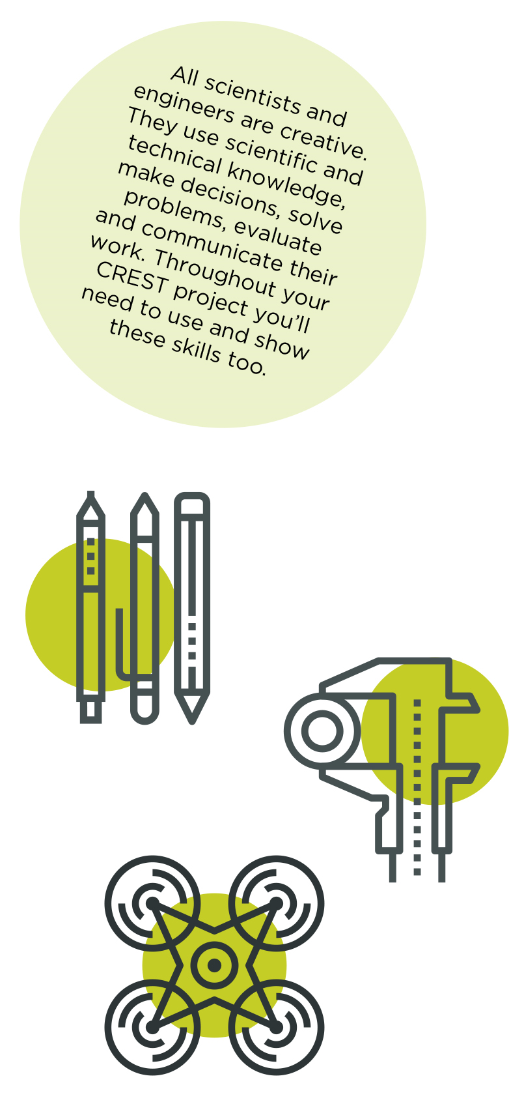

This Profile form is suitable for CREST Bronze, Silver and Gold Awards. Always use in conjunction with corresponding Student Guide Documents.

Please fill in this profile form and submit it along with your report to EESW. This a requirement for your submission and an opportunity for you to reflect on your project further.

If you are working in a group, make sure that you fill in and submit a separate Student Profile Form for each individual.

Personal reflections
Now that you’ve finished your project, use this space to add further thoughts on what you did and evaluate each stage of the project process. The CREST Gold Award student guide gives an example of what to include. You can continue on a separate sheet if necessary and use diagrams or pictures if you want to.
- How my project was successful/not successful
- What I learned
- What impact the results of my project might have on other people/the wider world
- What I would have done to improve my work
- What I’d do to develop the project in the future

My mentor
What role did your mentor have in your project?
Ask your mentor to confirm that this project is your work by signing below.
  - Signature of mentor
  - Date

  - Space for further notes/ drawings/ reflections (optional)...

