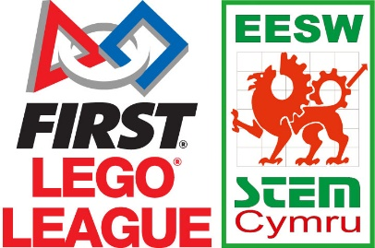

FIRST® LEGO® League Season 2019-2020 Registration Form

School: _______________________________
Address: ________________________________________________________
Post Code: ____________________________
(Please note your kit will be sent to this address)

Contact Name: __________________________
Contact E-mail Address: ________________________________
Contact Telephone Number: ____________________________

Team Name: ________________________________
How many children are in the team? (Max 10) ____________________
Year Group: _______________________

Are you new to FIRST® LEGO® League? Yes / No

How did you hear about FIRST® LEGO® League? _________________________

Please note that you will need to have an EV3 Lego Mindstorms Kit to participate in the competition. Alternatively, you can also take part with a SPIKE Prime set. EESW have a limited supply of EV3 kits which can be loaned to schools- please contact us for more information.
By signing this agreement, I understand that I will be required to attend the North or South Wales FLL regional final with a team of up to 10 students.
I agree that in the event of my school’s absence from the regional final, my school will become liable for the full entry cost of £150, plus VAT, payable to EESW. I understand that if I wish to enter a second team, I will have to pay the registration costs.

Signature: ________________________ Date: __________________________

