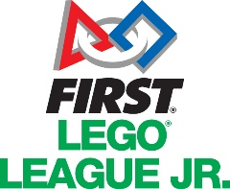
FIRST® LEGO® League Jr. Registration Form 2018–19

School:
Address:
Postcode:
(Please note your kit will be delivered to this address)

Contact Name:
Role/Department:
Email:
Phone:
Team Name:
No. of Pupils (max 6): Females: Males:
Year Group:
Have these pupils previously participated? Yes No

I understand that by signing this agreement, I will be required to attend the North or South Wales FLL regional final with a team of up to 6 students.

I am aware that I am responsible for the registration cost for the 2018-2019 competition and have read the requirements, including the need to access a Lego WeDo Robot for the duration of the challenge.

Signature: Date:

Please return this form to:

info@stemcymru.org.uk
EESW, Waterton Centre, Bridgend, CF31 3WT
Fax: 01656 662402

